
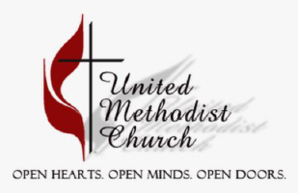
November 2026
The Extra Chair  By Kathy Hawkins  The Thanksgiving menu has received a lot of thought  And the carts of groceries have finally been bought  Paper napkins and matching paper plates  Will help make cleanup go at a speedy rate  The turkey in the oven at oh-so-early in the morning  Mashed potatoes spattered all over without warning  The stuffing, sweet potatoes, and corn on the side  Fill all the opens spots on the plate the rest did not hide  Pumpkin pie with whipped cream on top for dessert  There is no way you can eat it without getting some on your shirt  The places were set for those who were to attend  From family far and near as well as some great friends  As I look at all the faces sitting around the long table  From the squealy little ones to those not so able  An extra chair was added to include a special guest  For anyone who may not be so greatly blessed  We never know if that person who walks down the street    With ragged clothes and no shoes on their feet  Will be the one we have been waiting for from above  Who wraps arms around us in unconditional love  During this Thanksgiving season I pray you will find  The heart of the blessings is in loving and being kind | 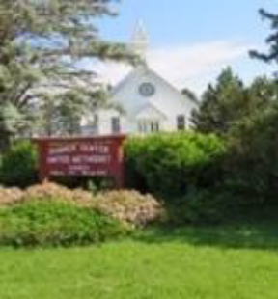  Sunday Worship:  In Sanctuary at 11:00 am  &  Sumner Center UMC  Facebook Page  Visit our Church Website at:  http://www.sumnercenter.com  Donations may be sent to our mailing address:  25378 151st Ave  Spring Valley, MN 55975  Also via Venmo and Paypal  Pastoral Support Team  Pastor Jon Marburger  Email: marburgerjon@gmail.com  Cell # 1-507-227-6711  Tony Derhaag  Email: derfahren@aol.com  Cell # 1-612-968-3811  Grace and Peace in the name of Jesus Christ: If you have items you would like to be published in the newsletter, please contact Jean McNamara or Kathy Hawkins by the 3rd Thursday of the preceding month by emailing your information or dropping at Church. The light of God remains to shine bright in our community only by your generous giving heart! If you would like to donate a gift, you may send donations to the address above or deliver it in person during Sunday morning worship service.

Calendar of Events
(Subject to change and/or be added to as the need arises)
November 2026

Sunday | Monday | Tuesday | Wednesday | Thursday | Friday | Saturday
1  11:00 am Worship    All Saints Day  Food Shelf offering | 2 | 3 | 4 | 5  SPRC meeting | 6 | 7
8  11:00 am Worship | 9 | 10 | 11 | 12 | 13 | 14
15  11:00 am Worship | 16 | 17 | 18 | 19 | 20 | 21  Annual Conf.  Spring Valley UMC – 9 a.m.
22  11:00 am Worship | 23 | 24 | 25  Ecumenical Thanksgiving Eve service  Zion UMC, Sargeant –  6:30 p.m. | 26  Thanksgiving   | 27 | 28
29  11:00 am Worship  1st Sunday of Advent  Hanging of the Greens after worship | 30

HANGING OF THE GREENS  Join us after worship service to decorate our beautiful church for the Advent season on Nov. 29. | ANGEL TREE  Donations for Christmas gifts for needy Fillmore County children due to Jean McNamara by Nov. 22.

Message from Pastor Tony

The holiday of Thanksgiving dominates the month. How thankful are you? But, more importantly are your thoughts of thankfulness centered around God? All we have comes from the blessing of Almighty God.

Our minds relate to our senses. What we feel, touch, smell, hear and see. We sense the end of fall and we may think that the difficulties of winter will be upon us very soon. The warmth of summer is over, except for maybe a couple of days this month. Thanksgiving offers us a time to again center around what we have been blessed with, rather than dwelling on the summer that is over.

Each time I travel the distance to get to Sunday services or church council meetings, I thank God for travel mercies He has granted me. This past summer, the summer rains showed me how God guided me. The heavy rains brought on reduced visibility, yet God guided me by watching over me with safe travel. Thank you, Heavenly Father, for your care. I do not worry about what the coming winter travel has in store, as God is there always for all of us.

Then when the Christmas season ends, Lent will not be far behind. Not only will the winter travel have Sunday services and church council meetings, but nearly two months of extra Wednesday Lenten services as well. It will be an opportunity to thank God even more, especially for the extra evenings to come together to commemorate the great love Christ displayed as we celebrate Holy Week after the Lenten Season.


One of the comments I had when I had the interview for assisting Pastor Jon, was this. A battleship is safest in the harbor, but that is not the purpose for which it is built. By knowing the force that is behind me is greater than any obstacle that is in front of me, I look forward to each opportunity to do all I can to build God’s Kingdom through service to him. Thank you, Heavenly Father, for granting me the privilege to serve in Your Kingdom.

Pastor Tony
Co-pastor of the Prairieland Parish



Message from Pastor Jon

Fall is upon us. The chill in the air reminds us that summer days have gone for the season. Where I notice the seasonal change most is in the morning. A few days ago I finally decided I would need some heat to deal with cooler temperatures. My furnace decided not to oblige my desire for some heat. Thankfully, the parsonage does a good job of maintaining heat through the evening and early morning. The temperature never dipped below 55 degrees. An extra blanket to help me sleep was all I needed to help me manage till repair work was done on the furnace. My gratitude that heating issues were handled promptly is significant. So often we can take small things like heat for granted. We just hit the thermostat, and expect things to work.

Everything we have and are is a gift from God. God created all things out of nothing. The vastness of the universe is a testament to the power and generosity of God. We are caretakers of what the Lord has provided to us. We simply use what God has placed in our care. Using wisely our resources is what is called stewardship. The month of November is the time in which we celebrate Thanksgiving. Many congregations often emphasize or have a stewardship drive during this month. My encouragement is that we look at stewardship continually rather than simply occasionally or one specific time.


Affordability is a real issue. Inflation is real. Many people are experiencing genuine financial issues in their lives. Supporting charitable institutions like our local food shelves are important year round. A warm place to live reminds me of the sad reality of those who currently are not having such an experience. Sadly, too many people do not have the basic necessities of life. May we bless other persons as we realize how God has blessed us. Thanksgiving is so much more than bountiful food and time spent with family. May our gratitude make a difference for Christ and His Kingdom.

Blessings,
Pastor Jon Marburger
Co-pastor of the Prairieland Parish


November Worship Schedule

November 1, 2026 | Pastor Tony Leading / Betsey is pianist
November 1st gospel passage is the Beatitudes, to commemorate All Saints Day.

November 8, 2026 | Pastor Tony Leading / Margaret is pianist
November 8th gospel passage is the parable of the ten bridesmaids. Five did not bring any oil for their lamps and five did have oil for their lamps as the groom was delayed in his arrival time.

November 15, 2026 | Pastor Jon Leading / Betsey pianist
November 15th gospel passage is the parable of the talents. One person is given five talents and those five talents produce five more talents. A second person is given two talents and those two talents produce two more talents. The third person gets one talent and does nothing with that talent.

November 22, 2026 | Pastor Jon Leading / Kathy is pianist
November 22nd gospel passage is about judgment of the Nations, as the service is about Christ the King. This Sunday represents the end of the Church year. Advent begins next week which represents the beginning of the new church year.

November 29, 2026 | Pastor Tony Leading / Betsey is pianist

November 29th is the first Sunday of Advent. Scripture passage is from Isaiah as we prepare for the arrival of the new born Savior. All Sundays in Advent will have Old Testament readings that foretell of the birth of Jesus.

DATES TO REMEMBER
Nov. 1 – All Saints Day, during regular church service
Nov. 21 – Annual Conference, Spring Valley UMC, 9 a.m.
Nov. 25 – Ecumenical Thanksgiving Eve Service, Zion UMC Sargeant, 6:30 p.m.
Nov. 26 – THANKSGIVING
Nov. 29 – Hanging of the Greens, after regular service

ANGEL TREE MISSION
If you would like to contribute to the Fillmore County Angel Tree project (Christmas gifts for needy children), please give donations to Jean McNamara by Nov. 22. They are asking for $50 per child but a donation of any amount will gladly be accepted and appreciated.
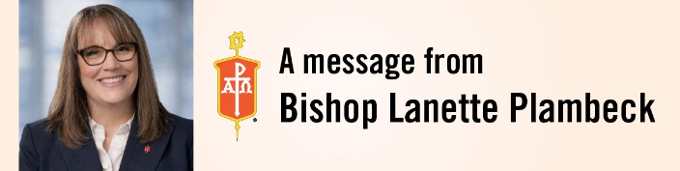
To the farmers, ranchers, and ag families across the Dakotas-Minnesota Episcopal Area and all who love them:

Grace and peace to you in the name of Jesus Christ, who knew the language of seed and soil, sheep and shepherd, sowing and harvest.

I miss the harvest rhythm of western Iowa. My faith journey began in Crawford County, and some part of me still keeps time by the seasons there: the hum of the combine at dusk, dust hanging in the late light, trucks lined up at the elevator, supper carried out to the field.

Now, as I travel across the Dakotas and Minnesota, I see that rhythm everywhere. Beet piles rising in the Red River Valley. Wheat and sunflowers across North and South Dakota. Wild rice gathered from northern Minnesota waters and grain coming off northern fields. Cattle coming home from summer pasture across our region. Corn and soybean fields stretching across southern Minnesota, with lights of farm equipment moving through the darkness long after most of us are asleep.

And I also know these are not easy days.

Costs are high. Markets are uncertain. Drought and changing weather have taken their toll. Decisions about land, livestock, debt, succession, and the future carry real weight. For some, this harvest comes with gratitude. For others, disappointment. For many, both.

I want you to know that your United Methodist family is paying attention.

Your church sees you. We give thanks for you. We are praying for you.

I also want to express my deep appreciation for your hard work and loyal labor. Day after day, season after season, you rise to responsibilities that demand patience, courage, skill, and sacrifice. You care for the land and animals entrusted to you, provide for your families and communities, and help sustain life far beyond the places where you live and work. Your labor is often unseen, but it is never unnoticed or unvalued. Thank you for the faithfulness with which you continue this work.

Scripture tells us that God placed humanity in the garden “to till it and keep it” (Genesis 2:15). There is something sacred in tending what God has entrusted to us. Every field harvested, every animal tended, every fence mended, every meal carried to someone working late participates in the work of sustaining life.

And when the work becomes heavy, hear again the invitation of Jesus: “Come to me, all you that are weary and are carrying heavy burdens, and I will give you rest” (Matthew 11:28).

Farming and ranching can be lonely and isolating work. Long hours, uncertainty, financial pressures, and the weight of responsibility can take a toll on mental health and well-being. We want you to know that your church is paying attention. You are not alone, and you do not have to carry every burden by yourself.

To our congregations across the Dakotas and Minnesota: pay attention to the farmers and ranchers among you. Pray for them by name. Check in. Take a meal. Sit over coffee. Notice who has become quiet or withdrawn. Learn the signs of farm stress. Be the kind of church where someone can say, “This is hard,” without having to pretend otherwise.

As harvest continues, I am praying for your safety and security, for your families and livelihoods, and for the land and animals entrusted to your care.

May God watch over your fields, your herds, your homes, and your families. May Christ meet you in both abundance and uncertainty. And may the Holy Spirit bind us together so that no one carries the harvest alone.

Let us pray:
God of seedtime and harvest, bless those who work the land. Keep safe those who rise before the sun and return home long after it has set. Bless the harvest gathered in and hold tenderly the disappointment of when the expense is higher than the earning. Where the numbers do not add up, give wisdom. Where uncertainty presses hard, give courage. Where bodies are weary, give rest. Where spirits are burdened, send companions. Protect those working machinery, hauling grain, tending livestock, and traveling tired roads. Bless the land, the animals, the families, and the communities that depend upon them. And remind us that those who feed the world should never feel forgotten by it. God of every season, make us faithful stewards of what you have entrusted to us, good neighbors to one another, and people who trust your presence in planting, in harvest, and in all that lies between. In the name of Jesus Christ, the Sower and the Good Shepherd. Amen.

With gratitude and prayer,

Bishop Lanette Plambeck
Resident Bishop
Dakotas-Minnesota Episcopal Area of The United Methodist Church

November Word Find

J | X | O | F | P | E | R | S | E | C | U | T | E | D | Z
Q | R | E | G | N | U | H | M | E | R | C | I | F | U | L
Z | C | I | Q | Z | J | F | K | Q | Z | G | R | E | A | T
P | K | N | G | V | S | P | I | R | I | T | J | Q | Z | K
E | V | H | Z | H | X | M | N | Z | F | I | L | L | E | D
A | H | E | A | R | T | Q | G | V | T | H | I | R | S | T
C | Z | R | V | X | Y | E | D | K | W | E | Z | V | Z | E
E | Q | I | K | Q | V | G | O | D | Q | A | X | Q | P | L
M | R | T | L | M | K | B | M | U | X | V | J | Z | O | I
A | E | K | M | E | J | V | Z | Y | S | E | Q | X | O | V
K | W | P | P | R | M | W | Q | V | Y | N | V | J | R | E
E | A | U | B | C | O | M | F | O | R | T | E | D | Q | R
R | R | R | W | Y | U | E | K | B | L | E | S | S | E | D
V | D | E | J | X | R | E | V | G | L | A | D | Z | S | Q
X | M | B | Q | M | N | K | M | R | E | J | O | I | C | E

BLESSED  COMFORTED  FILLED  GLAD  GOD  GREAT | HEART  HEAVEN  HUNGER  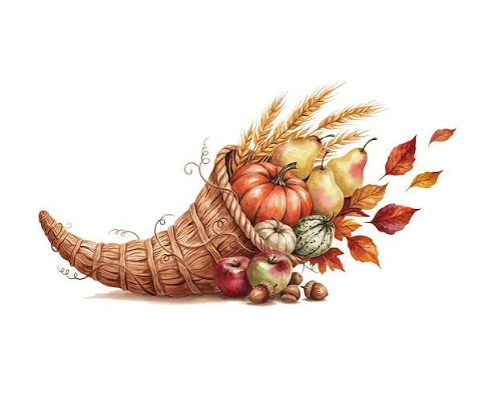  INHERIT  KINGDOM  MEED | MERCIFUL  MERCY  MOURN  PEACEMAKER  PERSECUTED  POOR | PURE  REVILE  REWARD  REJOICE  RIGHTEOUSNESS  SPIRIT  THIRST

